Workshop: hello world

1. Write a PL/SQL program that displays the message 'Hello World!'. The sending of this message must be accomplished using a single call to the DBMS_OUTPUT package. Run the program to confirm the result

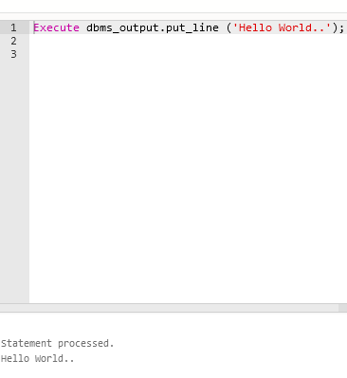

2. Write a PL/SQL program that displays the message 'Hello World!'. In this program, you must use two calls to the DBMS_OUTPUT package. The first call will send 'Hello' and the second call will send 'World!'. The message must display as a single line, as in step 2. Run the program to confirm the result.

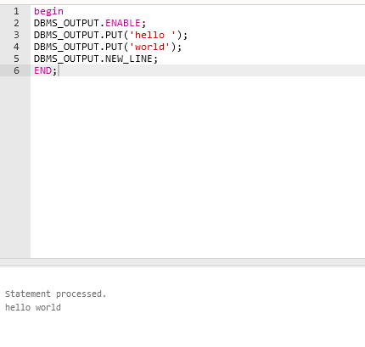

3 . Write a PL/SQL program that displays the message 'Hello World!'. The program must declare two variables, H and W:

(1)H must be declared as varchar2(15) and initialized to 'Hello'

(2)W must be declared as varchar2(15) and initialized to 'World!’

The program must make three calls to the DBMS_OUTPUT package to return the message:

(1)Return/Display the variable H

(2)Return/Display the variable W

(3)Return/Display the literal '!'

The values returned to the client must display as a single line, as in step 2. Run the program to confirm the result

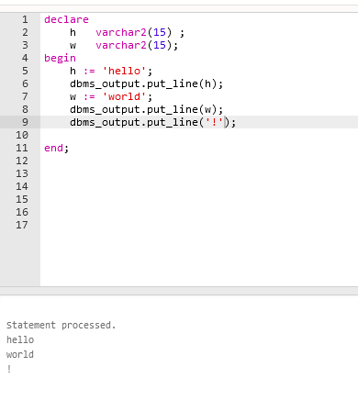

4. Write a PL/SQL program that displays the message 'Hello World!'. The program must declare two variables:

(1)H must be declared as varchar2(15) and initialized to 'Hello'

(2)W must be declared as varchar2(15) and initialized to 'World! '

The program must make a single call to the DBMS_OUTPUT package that causes the message to display as a single line, as in the previous step. Run the program to confirm the result.

